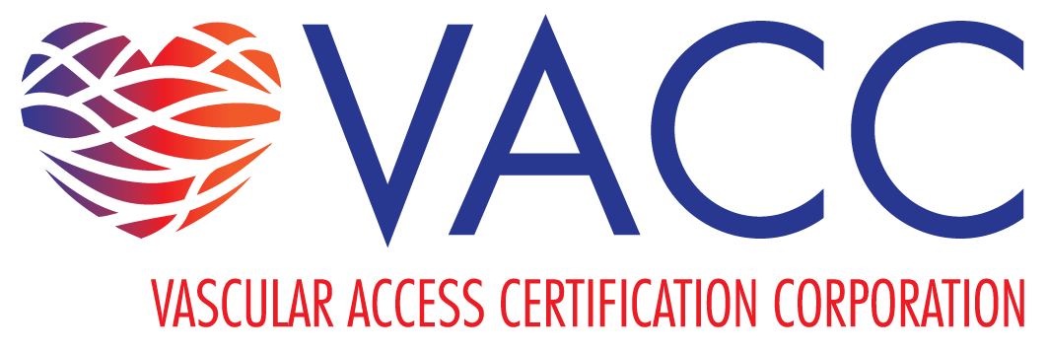

PRESS RELEASE

This sample press release may be duplicated on your organization’s letterhead.

[DATE]
[CONTACT NAME/PHONE/EMAIL]

FOR IMMEDIATE RELEASE

[Facility Name] Celebrates [# of certified clinicians] Board Certified Nurses on Certified Nurses Day
[Your City, Your State] – [Employer/Facility Name] is pleased to recognize the following [# of certified clinicians] board certified clinicians on March 19, 2025, for Certified Nurses Day.
[List names and specialty certifications for each board-certified nurse, line by line.]
Certification promotes clinicians who take the extra step to solidify their specialty knowledge and provide quality care. As healthcare and the nurse’s role become increasingly complex, specialty certifications are a sign of a dedicated, excelling, and skilled clinician.
[Please note: include a quote from yourself or your employer regarding these achievements for the press release.]

Certification is voluntary. Nurses can gain board certifications in several specialties, including vascular access, oncology, emergency nursing, pediatrics, and more. A primary purpose of certification is the protection of the public through a means of measurement of current skills and knowledge through a standardized comprehensive examination.
Please join us in celebrating these skilled, passionate clinicians for their impressive achievements!

For more information on [Employer Name], contact [Contact Name] at [Phone Number].

# # #

